Hunters of Reloria Game
Logic Puzzle
Five of the Hunters of Reloria are having a break from the quest at a tavern. Identify each Hunter by name and race as well as which weapon they use and what they have to drink.
To win an ebook prize, message Kasper with the name of the Hunter who drinks the Honey Mead.

 |  | Drink |  |  |  |  | Weapon |  |  |  |  | Race
 |  | Honey Mead | Ale | Whisky | Caco | Wine | Sword | Fire | Axe | Bow | Magic | Mage | Dragon | Knight | Dwarf | Halfling
Hero | Asher |  |  |  |  |  |  |  |  | X
 | Baja |  |  |  |  |  |  |  |  | X
 | Sienna |  |  |  |  |  | X | X | X | √ | X
 | Varnon |  |  |  |  |  |  |  |  | X
 | Violetta |  |  |  |  |  |  |  |  | X
Race | Mage
 | Dragon
 | Knight
 | Dwarf
 | Halfling
Weapon | Sword
 | Fire
 | Axe
 | Bow
 | Magic
Clues:
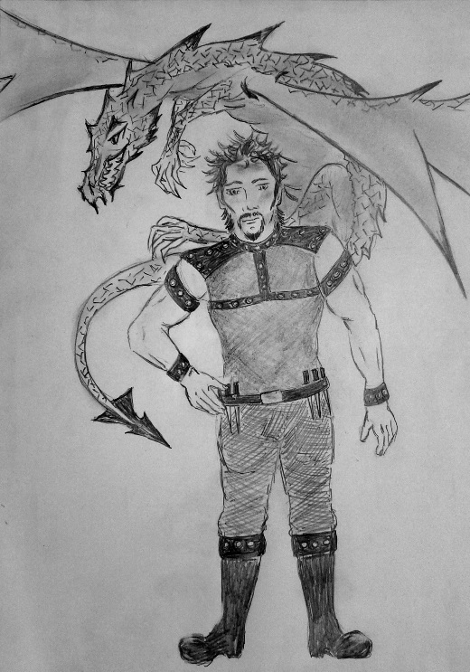
- Archer Sienna discovered she likes to drink hot Caco.
- The barmaids bring a large glass for the dragon who incinerated his enemies with fire.
- The Hunter who used the sword was taller than Baja Dwarf.
- Mage Violetta has five magical powers.
- Sir Varnon lounged beside the hearth with a goblet of mulled wine.
- The dwarf cracked open a large barrel of ale.
- Neither the mage nor the knight enjoy the taste of whisky.

To win an ebook prize, message Kasper with the name of the Hunter who drinks the Honey Mead.

